Lab 8 Report
Name: Võ Hoàng Nam
ID: ITITWE22118
PART A: IN-CLASS EXERCISES
Task 1.1: Create Spring Boot Project
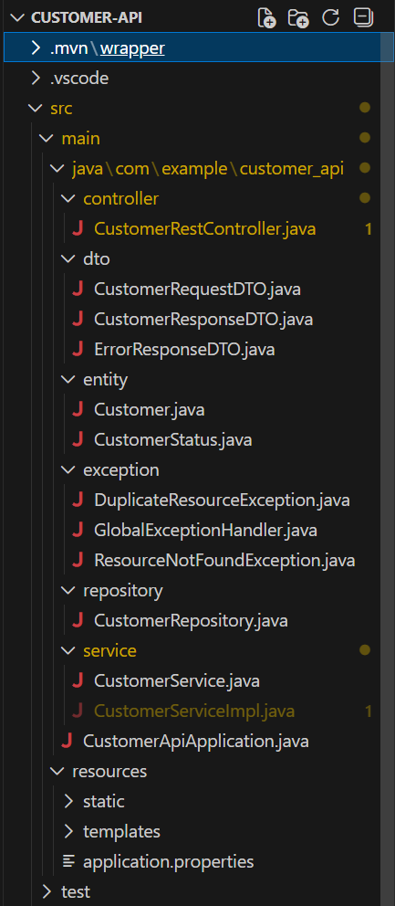

Configure application.properties:
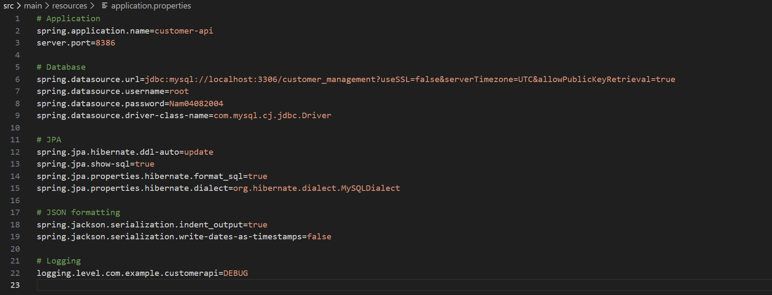

Task 1.3: Create Customer Entity
@Entity
@Table(name = "customers")
public class Customer {
@Id
@GeneratedValue(strategy = GenerationType.IDENTITY)
private Long id;
@Column(name = "customer_code", unique = true, nullable = false, length = 20)
private String customerCode;
@Column(name = "full_name", nullable = false, length = 100)
private String fullName;
@Column(unique = true, nullable = false, length = 100)
private String email;
@Column(length = 20)
private String phone;
@Column(columnDefinition = "TEXT")
private String address;
@Enumerated(EnumType.STRING)
@Column(nullable = false, length = 20)
private CustomerStatus status = CustomerStatus.ACTIVE;
@Column(name = "created_at", updatable = false)
private LocalDateTime createdAt;
@Column(name = "updated_at")
private LocalDateTime updatedAt;
@PrePersist
protected void onCreate() {
this.createdAt = LocalDateTime.now();
this.updatedAt = LocalDateTime.now();
}
@PreUpdate
protected void onUpdate() {
this.updatedAt = LocalDateTime.now();
}
// Constructors
public Customer() {
}
public Customer(String customerCode, String fullName, String email, String phone, String address) {
this.customerCode = customerCode;
this.fullName = fullName;
this.email = email;
this.phone = phone;
this.address = address;
}
// Getters and Setters
public Long getId() {
return id;
}
public void setId(Long id) {
this.id = id;
}
public String getCustomerCode() {
return customerCode;
}
public void setCustomerCode(String customerCode) {
this.customerCode = customerCode;
}
public String getFullName() {
return fullName;
}
public void setFullName(String fullName) {
this.fullName = fullName;
}
public String getEmail() {
return email;
}
public void setEmail(String email) {
this.email = email;
}
public String getPhone() {
return phone;
}
public void setPhone(String phone) {
this.phone = phone;
}
public String getAddress() {
return address;
}
public void setAddress(String address) {
this.address = address;
}
public CustomerStatus getStatus() {
return status;
}
public void setStatus(CustomerStatus status) {
this.status = status;
}
public LocalDateTime getCreatedAt() {
return createdAt;
}
public void setCreatedAt(LocalDateTime createdAt) {
this.createdAt = createdAt;
}
public LocalDateTime getUpdatedAt() {
return updatedAt;
}
public void setUpdatedAt(LocalDateTime updatedAt) {
this.updatedAt = updatedAt;
}
}
public enum CustomerStatus {
ACTIVE,
INACTIVE
}
EXERCISE 2: DTO LAYER
Task 2.1: Create Request DTO
public class CustomerRequestDTO {
@NotBlank(message = "Customer code is required")
@Size(min = 3, max = 20, message = "Customer code must be 3-20 characters")
@Pattern(regexp = "^C\\d{3,}$", message = "Customer code must start with C followed by numbers")
private String customerCode;
@NotBlank(message = "Full name is required")
@Size(min = 2, max = 100, message = "Name must be 2-100 characters")
private String fullName;
@NotBlank(message = "Email is required")
@Email(message = "Invalid email format")
private String email;
@Pattern(regexp = "^\\+?[0-9]{10,20}$", message = "Invalid phone number format")
private String phone;
@Size(max = 500, message = "Address too long")
private String address;
private String status;
// Constructors
public CustomerRequestDTO() {
}
public CustomerRequestDTO(String customerCode, String fullName, String email, String phone, String address) {
this.customerCode = customerCode;
this.fullName = fullName;
this.email = email;
this.phone = phone;
this.address = address;
}
// Getters and Setters
public String getCustomerCode() {
return customerCode;
}
public void setCustomerCode(String customerCode) {
this.customerCode = customerCode;
}
public String getFullName() {
return fullName;
}
public void setFullName(String fullName) {
this.fullName = fullName;
}
public String getEmail() {
return email;
}
public void setEmail(String email) {
this.email = email;
}
public String getPhone() {
return phone;
}
public void setPhone(String phone) {
this.phone = phone;
}
public String getAddress() {
return address;
}
public void setAddress(String address) {
this.address = address;
}
public String getStatus() {
return status;
}
public void setStatus(String status) {
this.status = status;
}
}
Task 2.2: Create Response DTO
public class CustomerResponseDTO {
private Long id;
private String customerCode;
private String fullName;
private String email;
private String phone;
private String address;
private String status;
private LocalDateTime createdAt;
// Constructors
public CustomerResponseDTO() {
}
public CustomerResponseDTO(Long id, String customerCode, String fullName, String email,
String phone, String address, String status, LocalDateTime createdAt) {
this.id = id;
this.customerCode = customerCode;
this.fullName = fullName;
this.email = email;
this.phone = phone;
this.address = address;
this.status = status;
this.createdAt = createdAt;
}
// Getters and Setters
public Long getId() {
return id;
}
public void setId(Long id) {
this.id = id;
}
public String getCustomerCode() {
return customerCode;
}
public void setCustomerCode(String customerCode) {
this.customerCode = customerCode;
}
public String getFullName() {
return fullName;
}
public void setFullName(String fullName) {
this.fullName = fullName;
}
public String getEmail() {
return email;
}
public void setEmail(String email) {
this.email = email;
}
public String getPhone() {
return phone;
}
public void setPhone(String phone) {
this.phone = phone;
}
public String getAddress() {
return address;
}
public void setAddress(String address) {
this.address = address;
}
public String getStatus() {
return status;
}
public void setStatus(String status) {
this.status = status;
}
public LocalDateTime getCreatedAt() {
return createdAt;
}
public void setCreatedAt(LocalDateTime createdAt) {
this.createdAt = createdAt;
}
}
Task 2.3: Create Error Response DTO
public class ErrorResponseDTO {
private LocalDateTime timestamp;
private int status;
private String error;
private String message;
private String path;
private List<String> details;
public ErrorResponseDTO() {
this.timestamp = LocalDateTime.now();
}
public ErrorResponseDTO(int status, String error, String message, String path) {
this.timestamp = LocalDateTime.now();
this.status = status;
this.error = error;
this.message = message;
this.path = path;
}
// Getters and Setters
public LocalDateTime getTimestamp() {
return timestamp;
}
public void setTimestamp(LocalDateTime timestamp) {
this.timestamp = timestamp;
}
public int getStatus() {
return status;
}
public void setStatus(int status) {
this.status = status;
}
public String getError() {
return error;
}
public void setError(String error) {
this.error = error;
}
public String getMessage() {
return message;
}
public void setMessage(String message) {
this.message = message;
}
public String getPath() {
return path;
}
public void setPath(String path) {
this.path = path;
}
public List<String> getDetails() {
return details;
}
public void setDetails(List<String> details) {
this.details = details;
}
}
EXERCISE 3: REPOSITORY & SERVICE
Task 3.1: Create Repository
@Repository
public interface CustomerRepository extends JpaRepository<Customer, Long> {
Optional<Customer> findByCustomerCode(String customerCode);
Optional<Customer> findByEmail(String email);
boolean existsByCustomerCode(String customerCode);
boolean existsByEmail(String email);
List<Customer> findByStatus(String status);
@Query("SELECT c FROM Customer c WHERE " +
"LOWER(c.fullName) LIKE LOWER(CONCAT('%', :keyword, '%')) OR " +
"LOWER(c.email) LIKE LOWER(CONCAT('%', :keyword, '%')) OR " +
"LOWER(c.customerCode) LIKE LOWER(CONCAT('%', :keyword, '%'))")
List<Customer> searchCustomers(@Param("keyword") String keyword);
}
Task 3.2: Create Service Interface
public interface CustomerService {
List<CustomerResponseDTO> getAllCustomers();
CustomerResponseDTO getCustomerById(Long id);
CustomerResponseDTO createCustomer(CustomerRequestDTO requestDTO);
CustomerResponseDTO updateCustomer(Long id, CustomerRequestDTO requestDTO);
void deleteCustomer(Long id);
List<CustomerResponseDTO> searchCustomers(String keyword);
List<CustomerResponseDTO> getCustomersByStatus(String status);
}
Task 3.3: Implement Service
@Service
@Transactional
public class CustomerServiceImpl implements CustomerService {
private final CustomerRepository customerRepository;
@Autowired
public CustomerServiceImpl(CustomerRepository customerRepository) {
this.customerRepository = customerRepository;
}
@Override
public List<CustomerResponseDTO> getAllCustomers() {
return customerRepository.findAll()
.stream()
.map(this::convertToResponseDTO)
.collect(Collectors.toList());
}
@Override
public CustomerResponseDTO getCustomerById(Long id) {
Customer customer = customerRepository.findById(id)
.orElseThrow(() -> new ResourceNotFoundException("Customer not found with id: " + id));
return convertToResponseDTO(customer);
}
@Override
public CustomerResponseDTO createCustomer(CustomerRequestDTO requestDTO) {
// Check for duplicates
if (customerRepository.existsByCustomerCode(requestDTO.getCustomerCode())) {
throw new DuplicateResourceException("Customer code already exists: " + requestDTO.getCustomerCode());
}
if (customerRepository.existsByEmail(requestDTO.getEmail())) {
throw new DuplicateResourceException("Email already exists: " + requestDTO.getEmail());
}
// Convert DTO to Entity
Customer customer = convertToEntity(requestDTO);
// Save to database
Customer savedCustomer = customerRepository.save(customer);
// Convert Entity to Response DTO
return convertToResponseDTO(savedCustomer);
}
@Override
public CustomerResponseDTO updateCustomer(Long id, CustomerRequestDTO requestDTO) {
Customer existingCustomer = customerRepository.findById(id)
.orElseThrow(() -> new ResourceNotFoundException("Customer not found with id: " + id));
// Check if email is being changed to an existing one
if (!existingCustomer.getEmail().equals(requestDTO.getEmail())
&& customerRepository.existsByEmail(requestDTO.getEmail())) {
throw new DuplicateResourceException("Email already exists: " + requestDTO.getEmail());
}
// Update fields
existingCustomer.setFullName(requestDTO.getFullName());
existingCustomer.setEmail(requestDTO.getEmail());
existingCustomer.setPhone(requestDTO.getPhone());
existingCustomer.setAddress(requestDTO.getAddress());
// Don't update customerCode (immutable)
Customer updatedCustomer = customerRepository.save(existingCustomer);
return convertToResponseDTO(updatedCustomer);
}
@Override
public void deleteCustomer(Long id) {
if (!customerRepository.existsById(id)) {
throw new ResourceNotFoundException("Customer not found with id: " + id);
}
customerRepository.deleteById(id);
}
@Override
public List<CustomerResponseDTO> searchCustomers(String keyword) {
return customerRepository.searchCustomers(keyword)
.stream()
.map(this::convertToResponseDTO)
.collect(Collectors.toList());
}
@Override
public List<CustomerResponseDTO> getCustomersByStatus(String status) {
return customerRepository.findByStatus(status)
.stream()
.map(this::convertToResponseDTO)
.collect(Collectors.toList());
}
// Helper Methods for DTO Conversion
private CustomerResponseDTO convertToResponseDTO(Customer customer) {
CustomerResponseDTO dto = new CustomerResponseDTO();
dto.setId(customer.getId());
dto.setCustomerCode(customer.getCustomerCode());
dto.setFullName(customer.getFullName());
dto.setEmail(customer.getEmail());
dto.setPhone(customer.getPhone());
dto.setAddress(customer.getAddress());
dto.setStatus(customer.getStatus().toString());
dto.setCreatedAt(customer.getCreatedAt());
return dto;
}
private Customer convertToEntity(CustomerRequestDTO dto) {
Customer customer = new Customer();
customer.setCustomerCode(dto.getCustomerCode());
customer.setFullName(dto.getFullName());
customer.setEmail(dto.getEmail());
customer.setPhone(dto.getPhone());
customer.setAddress(dto.getAddress());
return customer;
}
}
EXERCISE 4: REST CONTROLLER
Task 4.1: Create Basic REST Controller
@RestController
@RequestMapping("/api/customers")
@CrossOrigin(origins = "*") // Allow CORS for frontend
public class CustomerRestController {
private final CustomerService customerService;
@Autowired
public CustomerRestController(CustomerService customerService) {
this.customerService = customerService;
}
// GET all customers
@GetMapping
public ResponseEntity<List<CustomerResponseDTO>> getAllCustomers() {
List<CustomerResponseDTO> customers = customerService.getAllCustomers();
return ResponseEntity.ok(customers);
}
// GET customer by ID
@GetMapping("/{id}")
public ResponseEntity<CustomerResponseDTO> getCustomerById(@PathVariable Long id) {
CustomerResponseDTO customer = customerService.getCustomerById(id);
return ResponseEntity.ok(customer);
}
// POST create new customer
@PostMapping
public ResponseEntity<CustomerResponseDTO> createCustomer(@Valid @RequestBody CustomerRequestDTO requestDTO) {
CustomerResponseDTO createdCustomer = customerService.createCustomer(requestDTO);
return ResponseEntity.status(HttpStatus.CREATED).body(createdCustomer);
}
// PUT update customer
@PutMapping("/{id}")
public ResponseEntity<CustomerResponseDTO> updateCustomer(
@PathVariable Long id,
@Valid @RequestBody CustomerRequestDTO requestDTO) {
CustomerResponseDTO updatedCustomer = customerService.updateCustomer(id, requestDTO);
return ResponseEntity.ok(updatedCustomer);
}
// DELETE customer
@DeleteMapping("/{id}")
public ResponseEntity<Map<String, String>> deleteCustomer(@PathVariable Long id) {
customerService.deleteCustomer(id);
Map<String, String> response = new HashMap<>();
response.put("message", "Customer deleted successfully");
return ResponseEntity.ok(response);
}
// GET search customers
@GetMapping("/search")
public ResponseEntity<List<CustomerResponseDTO>> searchCustomers(@RequestParam String keyword) {
List<CustomerResponseDTO> customers = customerService.searchCustomers(keyword);
return ResponseEntity.ok(customers);
}
// GET customers by status
@GetMapping("/status/{status}")
public ResponseEntity<List<CustomerResponseDTO>> getCustomersByStatus(@PathVariable String status) {
List<CustomerResponseDTO> customers = customerService.getCustomersByStatus(status);
return ResponseEntity.ok(customers);
}
}
Task 4.2: Add Exception Handling
public class DuplicateResourceException extends RuntimeException {
public DuplicateResourceException(String message) {
super(message);
}
public DuplicateResourceException(String message, Throwable cause) {
super(message, cause);
}
}
@RestControllerAdvice
public class GlobalExceptionHandler {
// Handle ResourceNotFoundException (404)
@ExceptionHandler(ResourceNotFoundException.class)
public ResponseEntity<ErrorResponseDTO> handleResourceNotFoundException(
ResourceNotFoundException ex,
WebRequest request) {
ErrorResponseDTO error = new ErrorResponseDTO(
HttpStatus.NOT_FOUND.value(),
"Not Found",
ex.getMessage(),
request.getDescription(false).replace("uri=", "")
);
return new ResponseEntity<>(error, HttpStatus.NOT_FOUND);
}
// Handle DuplicateResourceException (409)
@ExceptionHandler(DuplicateResourceException.class)
public ResponseEntity<ErrorResponseDTO> handleDuplicateResourceException(
DuplicateResourceException ex,
WebRequest request) {
ErrorResponseDTO error = new ErrorResponseDTO(
HttpStatus.CONFLICT.value(),
"Conflict",
ex.getMessage(),
request.getDescription(false).replace("uri=", "")
);
return new ResponseEntity<>(error, HttpStatus.CONFLICT);
}

// Handle Validation Errors (400)
@ExceptionHandler(MethodArgumentNotValidException.class)
public ResponseEntity<ErrorResponseDTO> handleValidationException(
MethodArgumentNotValidException ex,
WebRequest request) {
List<String> details = new ArrayList<>();
for (FieldError error : ex.getBindingResult().getFieldErrors()) {
details.add(error.getField() + ": " + error.getDefaultMessage());
}
ErrorResponseDTO error = new ErrorResponseDTO(
HttpStatus.BAD_REQUEST.value(),
"Validation Failed",
"Invalid input data",
request.getDescription(false).replace("uri=", "")
);
error.setDetails(details);
return new ResponseEntity<>(error, HttpStatus.BAD_REQUEST);
}
// Handle all other exceptions (500)
@ExceptionHandler(Exception.class)
public ResponseEntity<ErrorResponseDTO> handleGlobalException(
Exception ex,
WebRequest request) {
ErrorResponseDTO error = new ErrorResponseDTO(
HttpStatus.INTERNAL_SERVER_ERROR.value(),
"Internal Server Error",
ex.getMessage(),
request.getDescription(false).replace("uri=", "")
);
return new ResponseEntity<>(error, HttpStatus.INTERNAL_SERVER_ERROR);
}
}
public class ResourceNotFoundException extends RuntimeException {
public ResourceNotFoundException(String message) {
super(message);
}
public ResourceNotFoundException(String message, Throwable cause) {
super(message, cause);
}
}
TESTING WITH REST CLIENT
Test 1: GET All Customers
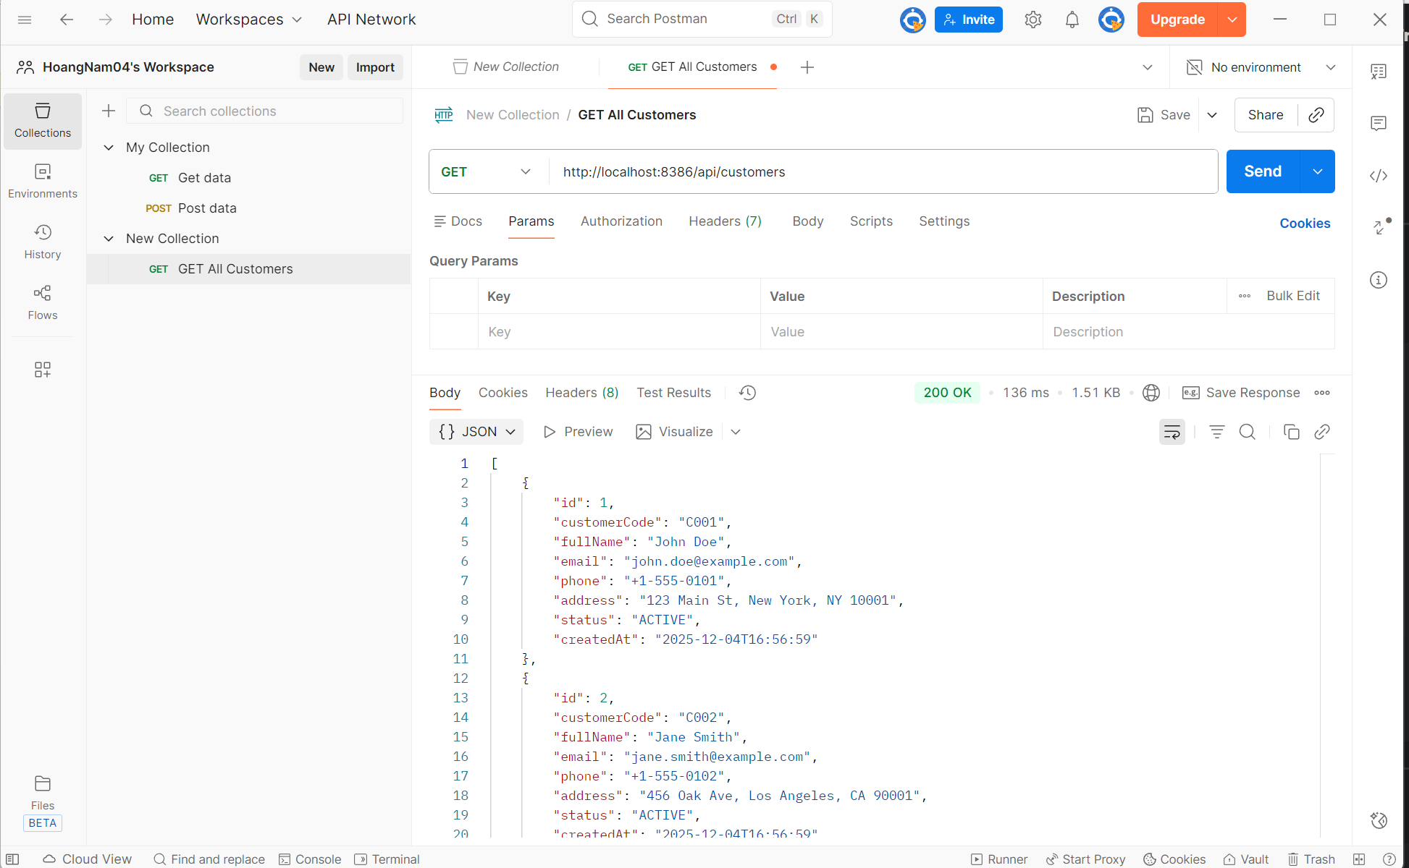
1. Objective: The purpose of this test was to verify the functionality of the "Get All Customers" API endpoint, ensuring that it correctly retrieves and displays the list of existing customers from the database.
2. Request Details
- Method: GET
- Request URL: http://localhost:8386/api/customers
- Environment: Localhost (Dev Environment)
- Parameters: No query parameters were used for this specific request.
3. Execution Results
- HTTP Status Code: 200 OK
  - Interpretation: The request was received, understood, and processed successfully by the server.
- Response Time: 136 ms
  - Interpretation: The server responded within an acceptable timeframe for a local environment.
4. Response Payload Analysis: The server returned a JSON array containing customer objects. Based on the response body:
- Data Structure: The API returns a list of objects, where each object represents a single customer entity.
- Fields Returned: The response correctly includes all necessary fields: id, customerCode, fullName, email, phone, address, status, and createdAt.
- Data Verification:
  - Record 1: Customer "C001" (John Doe) - Status: ACTIVE.
  - Record 2: Customer "C002" (Jane Smith) - Status: ACTIVE.
5. Conclusion The API endpoint is functioning correctly. It successfully connects to the backend service and retrieves the stored customer data in the expected JSON format without errors.

Test 2: GET Customer by ID
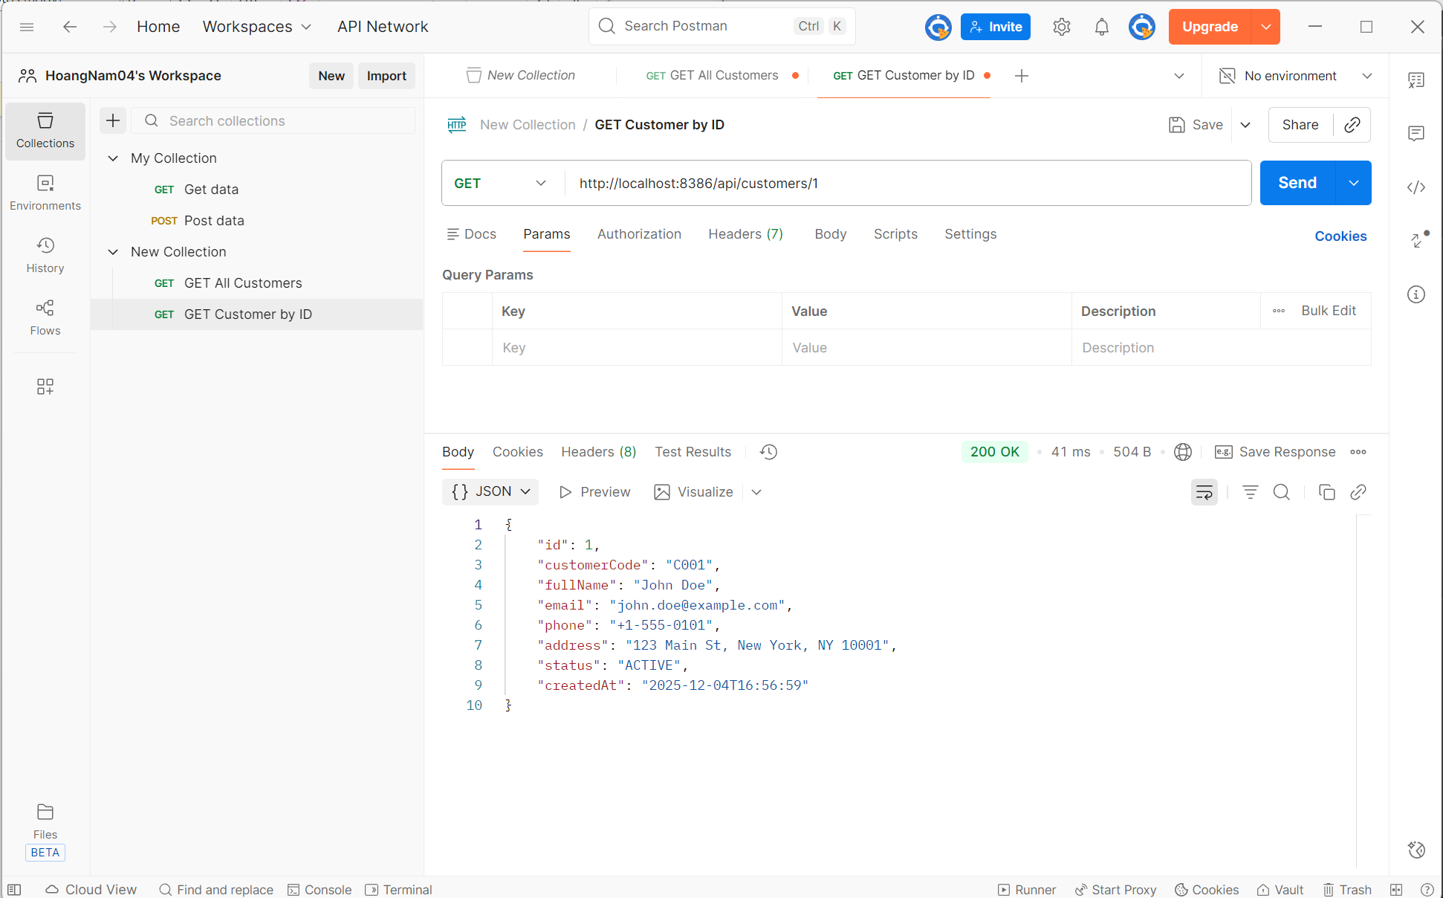
- Objective: To verify that the API endpoint correctly retrieves the specific details of a single customer when provided with a valid unique identifier (ID).
- Test Execution:
  - Request Method: GET
  - Request URL: http://localhost:8386/api/customers/1 (Testing for Customer ID: 1)
- Test Result:
  - Status Code: 200 OK (Indicates the resource was found and the request was successful).
  - Response Time: 41 ms.
  - Response Format: Single JSON Object.
- Data Analysis: The API successfully returned the object for the customer associated with ID 1. The data includes:
  - id: 1 (Matches the requested parameter)
  - customerCode: "C001"
  - fullName: "John Doe"
  - email: "john.doe@example.com"
  - status: "ACTIVE"
- Conclusion: The endpoint successfully handles requests for specific IDs and returns the correct individual record.
Test 3: POST Create Customer
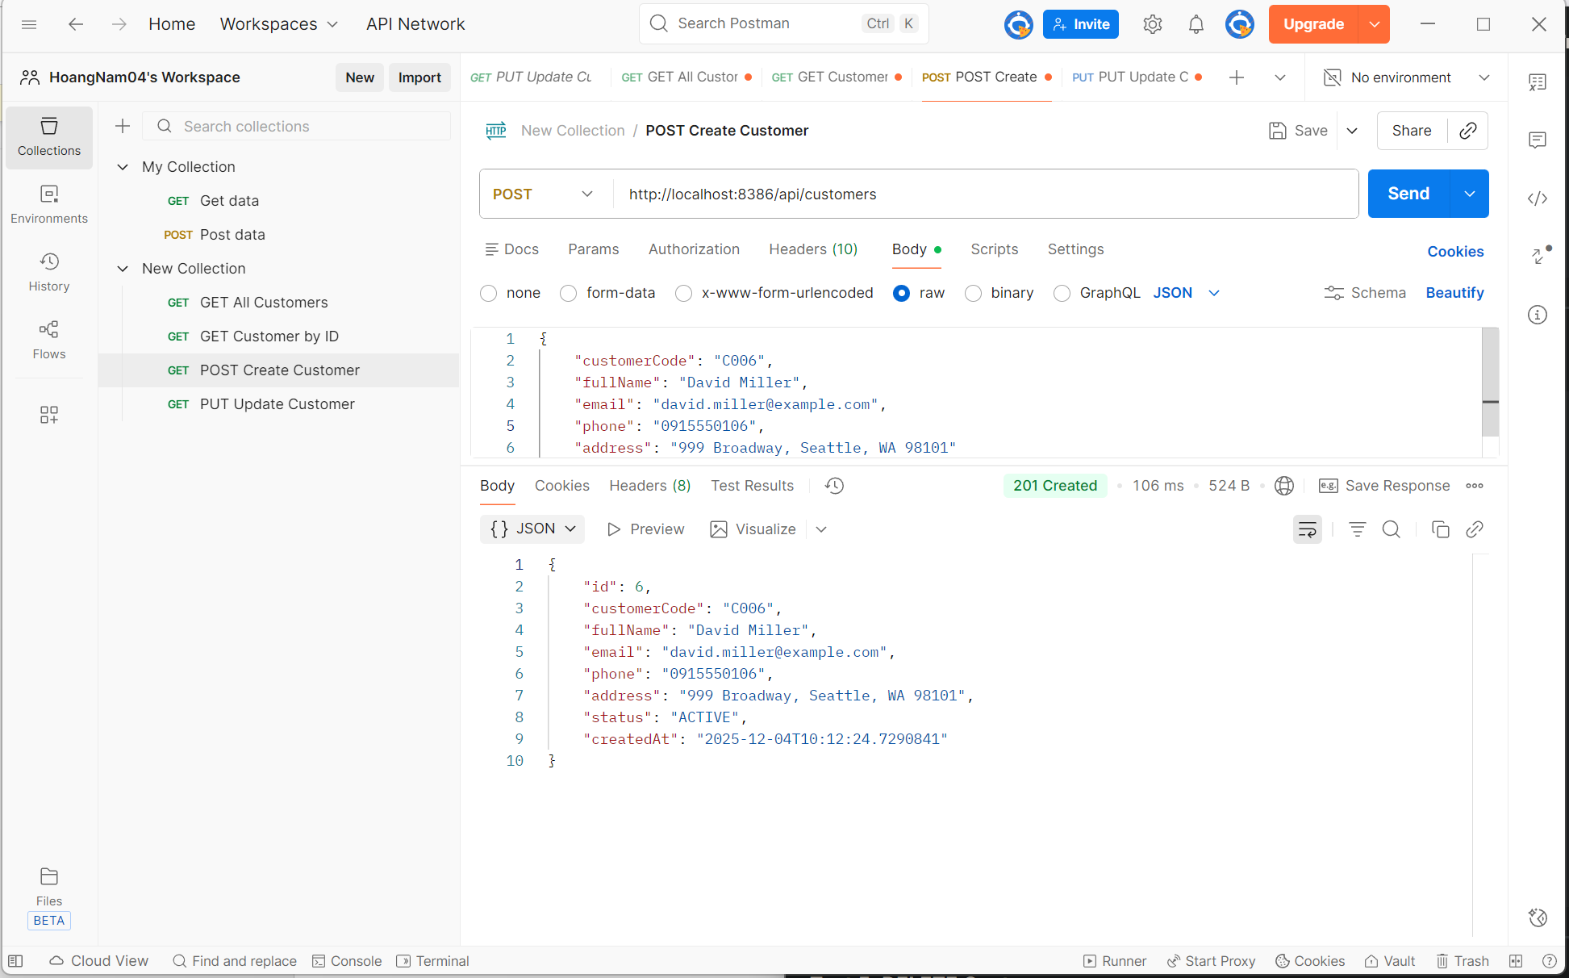
- Objective: To verify that the API endpoint allows for the successful creation of a new customer record in the database.
- Test Execution:
  - Request Method: POST
  - Request URL: http://localhost:8386/api/customers
  - Request Body (JSON): Sent customer details for "David Miller" including code C006, email david.miller@example.com, and phone 0915550106.
- Test Result:
  - Status Code: 201 Created (Indicates the resource was successfully created on the server).
  - Response Time: 106 ms.
  - Response Format: JSON Object.
- Data Analysis: The API returned the newly created customer object, confirming the data was saved.
  - Auto-generated Fields: The system correctly assigned a new unique id (6), set the status to "ACTIVE", and generated a createdAt timestamp.
  - Data Integrity: The returned fields (fullName, email, address) match the input data exactly.
- Conclusion: The "Create Customer" endpoint functions correctly, successfully processing the input payload and persisting the new record with a 201 status.

Test 4: PUT Update Customer
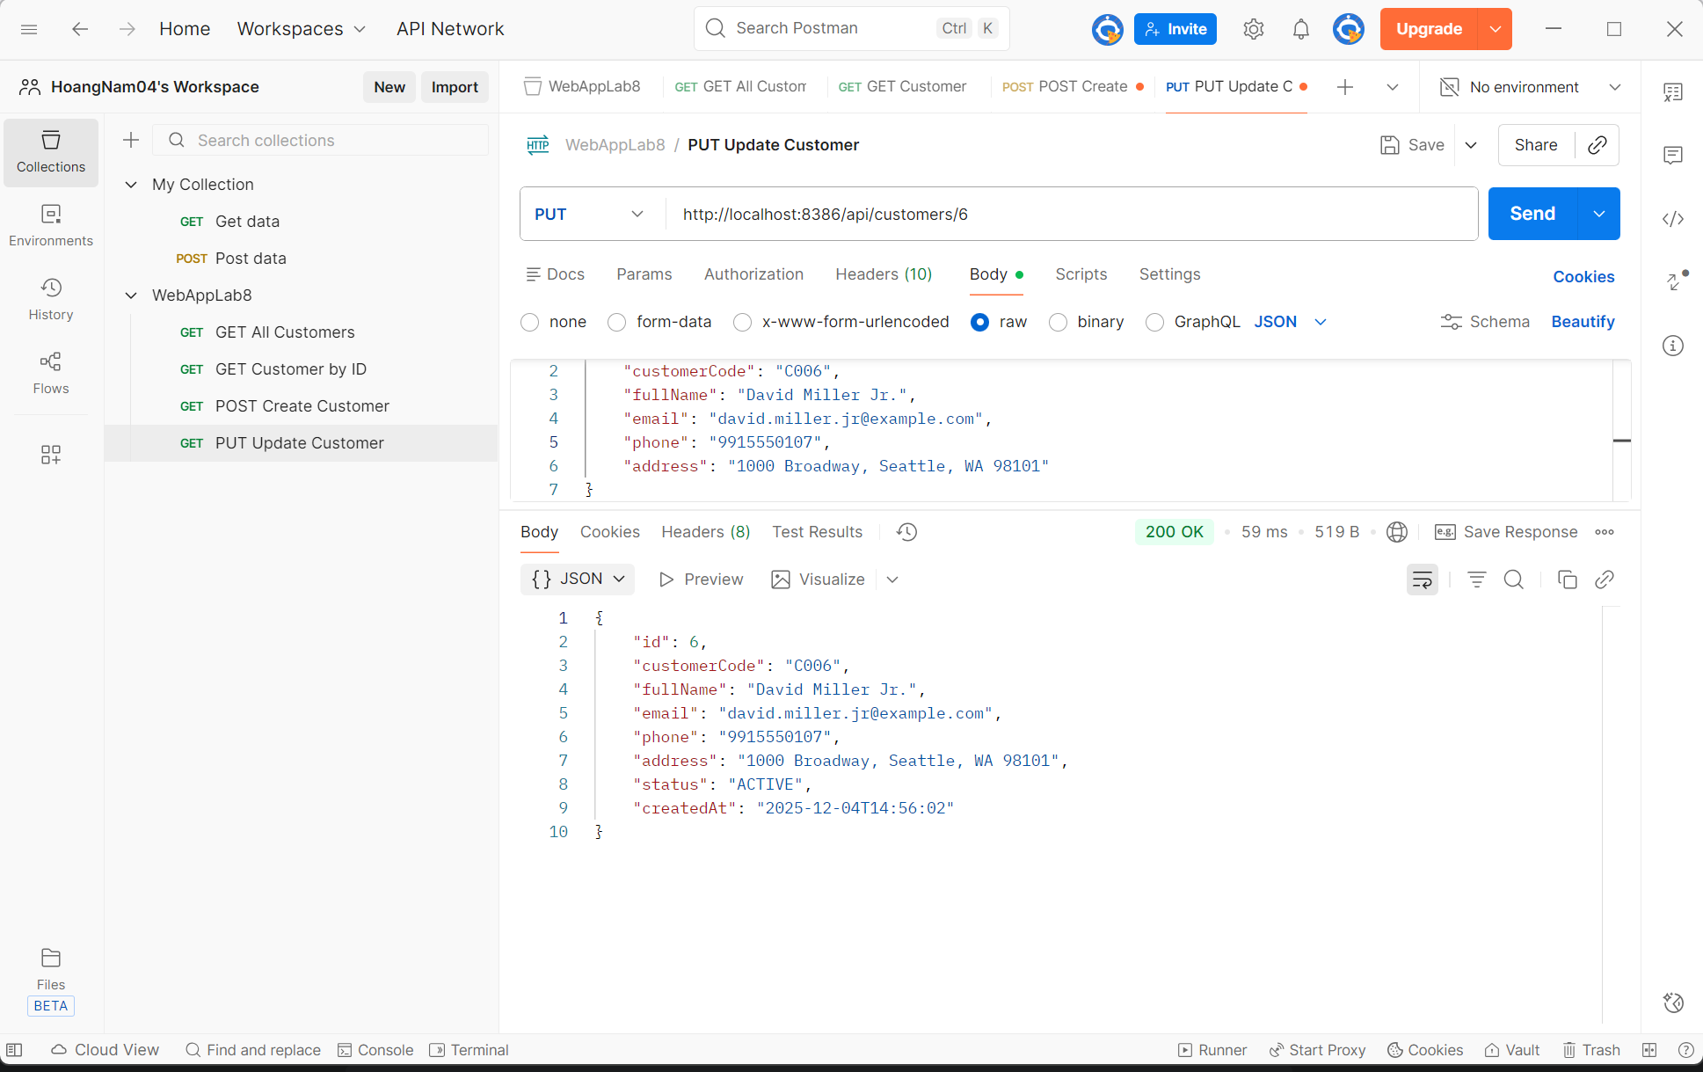
- Objective: To verify that the API endpoint correctly updates the details of an existing customer record identified by their unique ID.
- Test Execution:
  - Request Method: PUT
  - Request URL: http://localhost:8386/api/customers/6 (Targeting Customer ID: 6)
  - Request Body (JSON): Submitted updated information for "David Miller", changing the name to "David Miller Jr.", updating the email to "david.miller.jr@example.com", and modifying the address to "1000 Broadway".
- Test Result:
  - Status Code: 200 OK (Indicates the update was processed successfully).
  - Response Time: 59 ms.
  - Response Format: JSON Object.
- Data Analysis: The API returned the updated customer object, confirming that the changes were persisted in the database.
  - Identity Preservation: The id (6) and customerCode ("C006") remained consistent.
  - Field Updates: The fullName, email, phone, and address fields now reflect the new values submitted in the request body.
- Conclusion: The "Update Customer" endpoint functions correctly, modifying existing records without creating duplicates or altering immutable identifiers.
Test 5: DELETE Customer
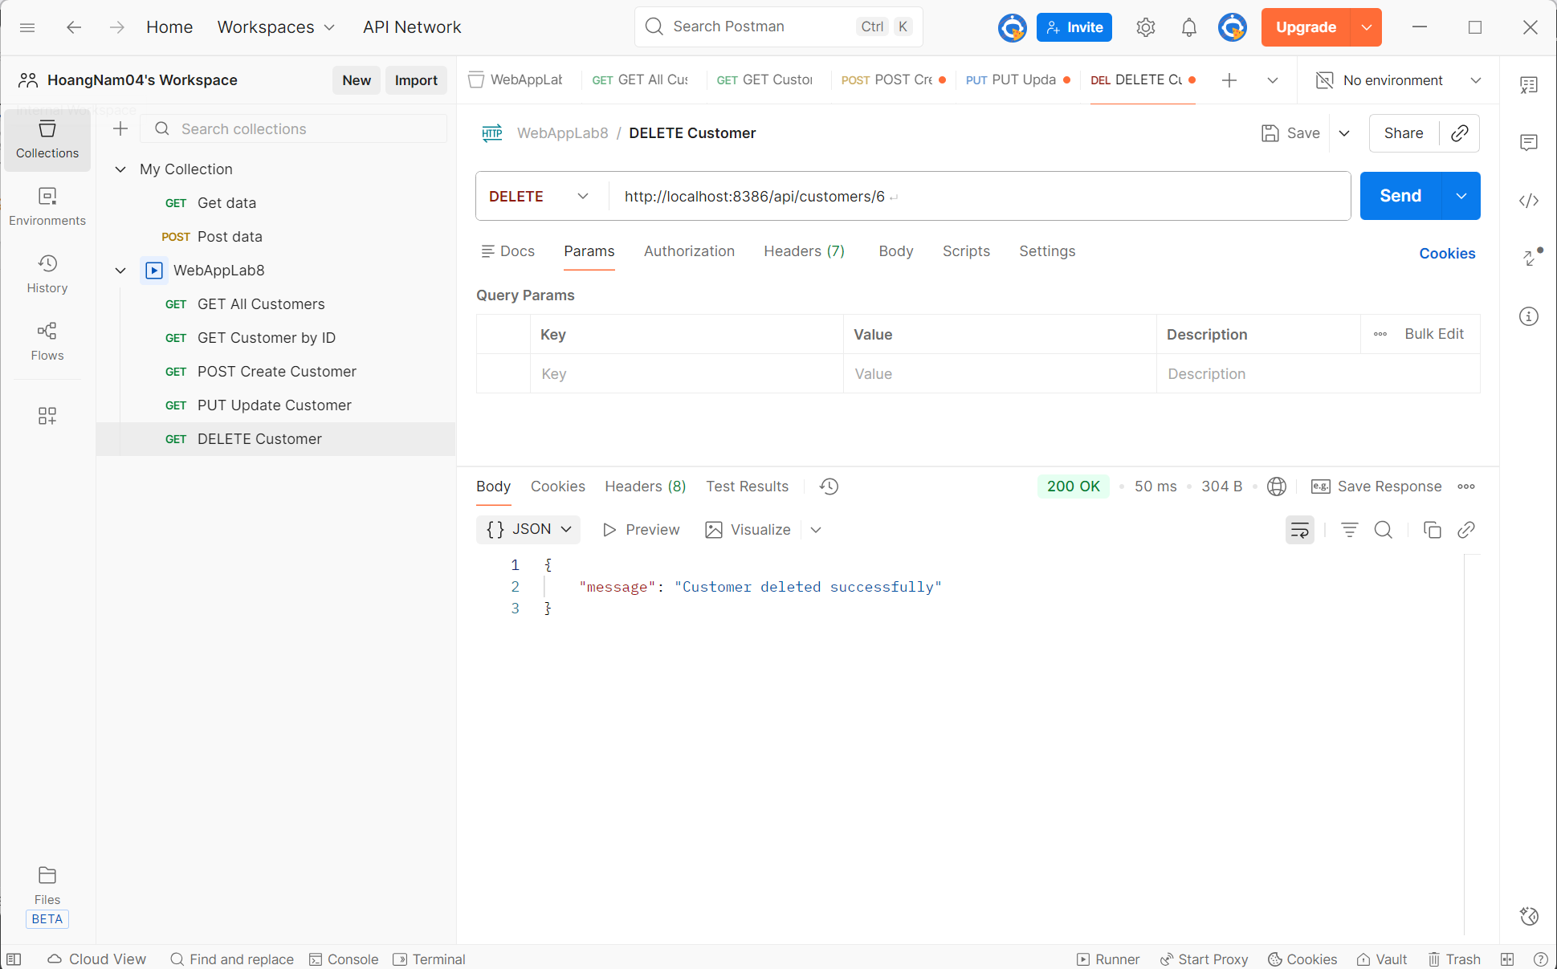
- Objective: To verify that the API endpoint allows for the removal of an existing customer record from the database using their unique ID.
- Test Execution:
  - Request Method: DELETE.
  - Request URL: http://localhost:8386/api/customers/6 (Targeting Customer ID: 6).
- Test Result:
  - Status Code: 200 OK (Indicates the server successfully processed the deletion request).
  - Response Time: 50 ms.
  - Response Format: JSON Object.
- Data Analysis: The server responded with a confirmation message rather than a customer object, which is standard for delete operations.
  - Message: "Customer deleted successfully".
- Conclusion: The "Delete Customer" endpoint functions correctly, removing the specified resource and returning a clear success confirmation.

Test 6: Search Customers

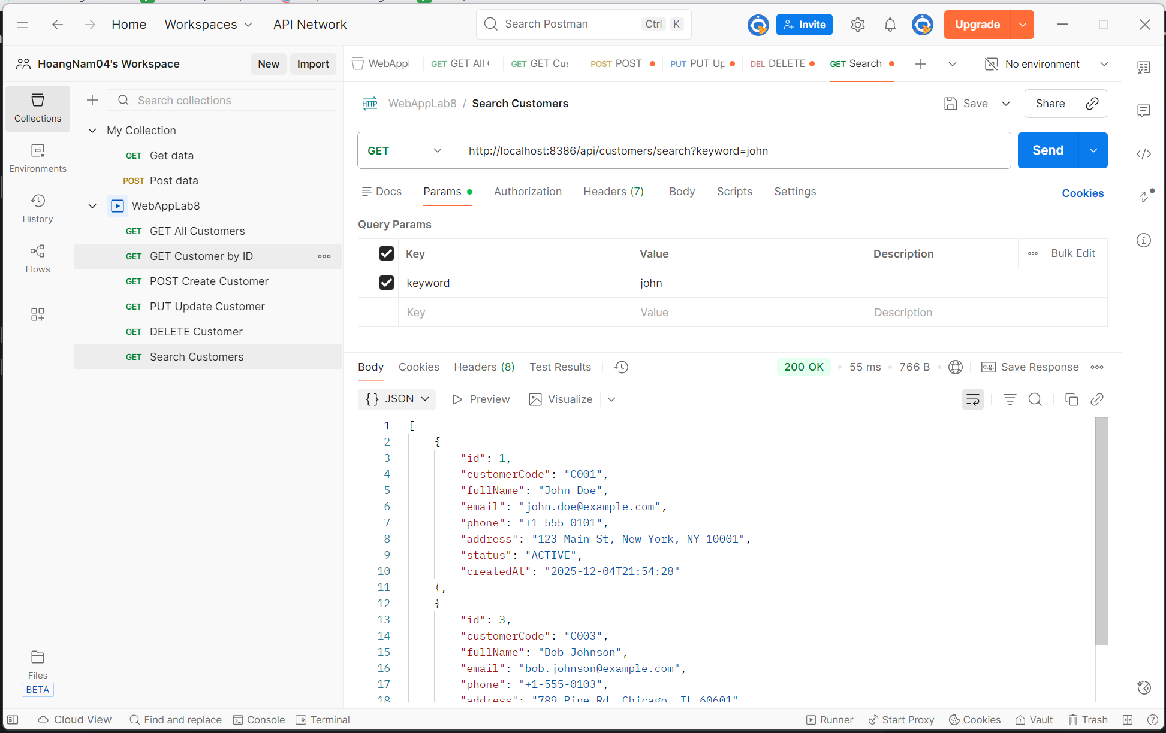
- Objective: To verify that the API endpoint correctly filters and retrieves customer records that match a specific search keyword.
- Test Execution:
  - Request Method: GET
  - Request URL: http://localhost:8386/api/customers/search?keyword=john
  - Query Parameters: keyword set to john.
- Test Result:
  - Status Code: 200 OK (Indicates the search query was processed successfully).
  - Response Time: 55 ms.
  - Response Format: JSON Array.
- Data Analysis: The API returned a list of customers containing the string "john" in their details, confirming the search logic works (likely case-insensitive and partial match).
  - Record 1: "John Doe" (Match on First Name).
  - Record 2: "Bob Johnson" (Match on Last Name/Email).
- Conclusion: The "Search Customers" endpoint functions correctly, returning relevant results based on the provided query parameter.

Test 7: Validation Error
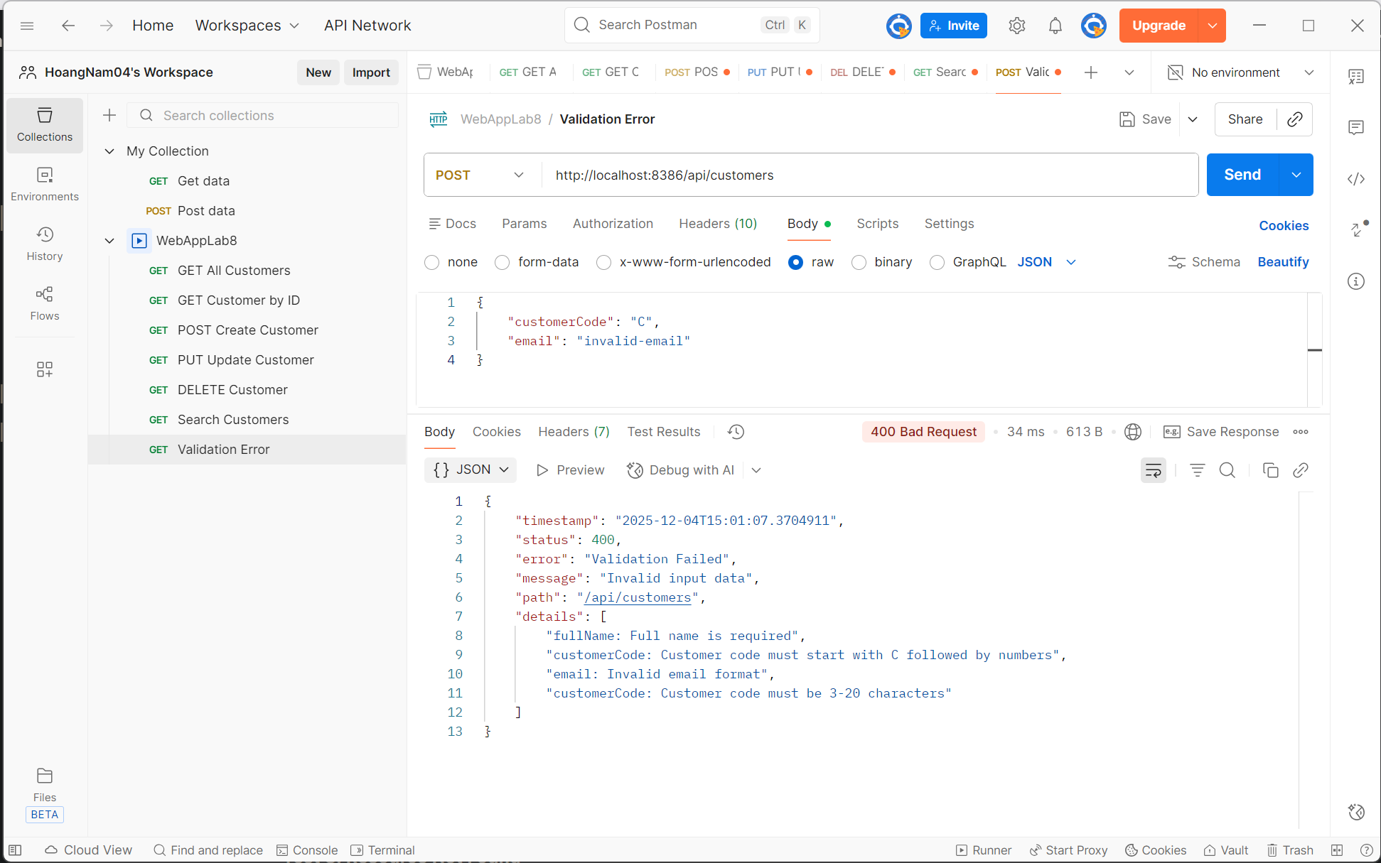
- Objective: To verify that the API correctly validates user input and returns appropriate error messages when mandatory fields are missing or format constraints are violated.
- Test Execution:
  - Request Method: POST.
  - Request URL: http://localhost:8386/api/customers.
  - Request Body (Invalid JSON): Submitted a payload with a missing fullName, an invalid customerCode ("C"), and a malformed email ("invalid-email").
- Test Result:
  - Status Code: 400 Bad Request (Indicates the server rejected the request due to client-side errors).
  - Response Time: 34 ms.
  - Response Format: JSON Error Object.
- Data Analysis: The API returned a structured error response containing a list of specific validation failures:
  - fullName: Flagged as "Full name is required".
  - customerCode: Flagged for length ("must be 3-20 characters") and format ("must start with C followed by numbers").
  - email: Flagged as "Invalid email format".
- Conclusion: The API correctly implements input validation, rejecting invalid data with a 400 status code and providing descriptive error messages to guide the user.

Test 8: Resource Not Found

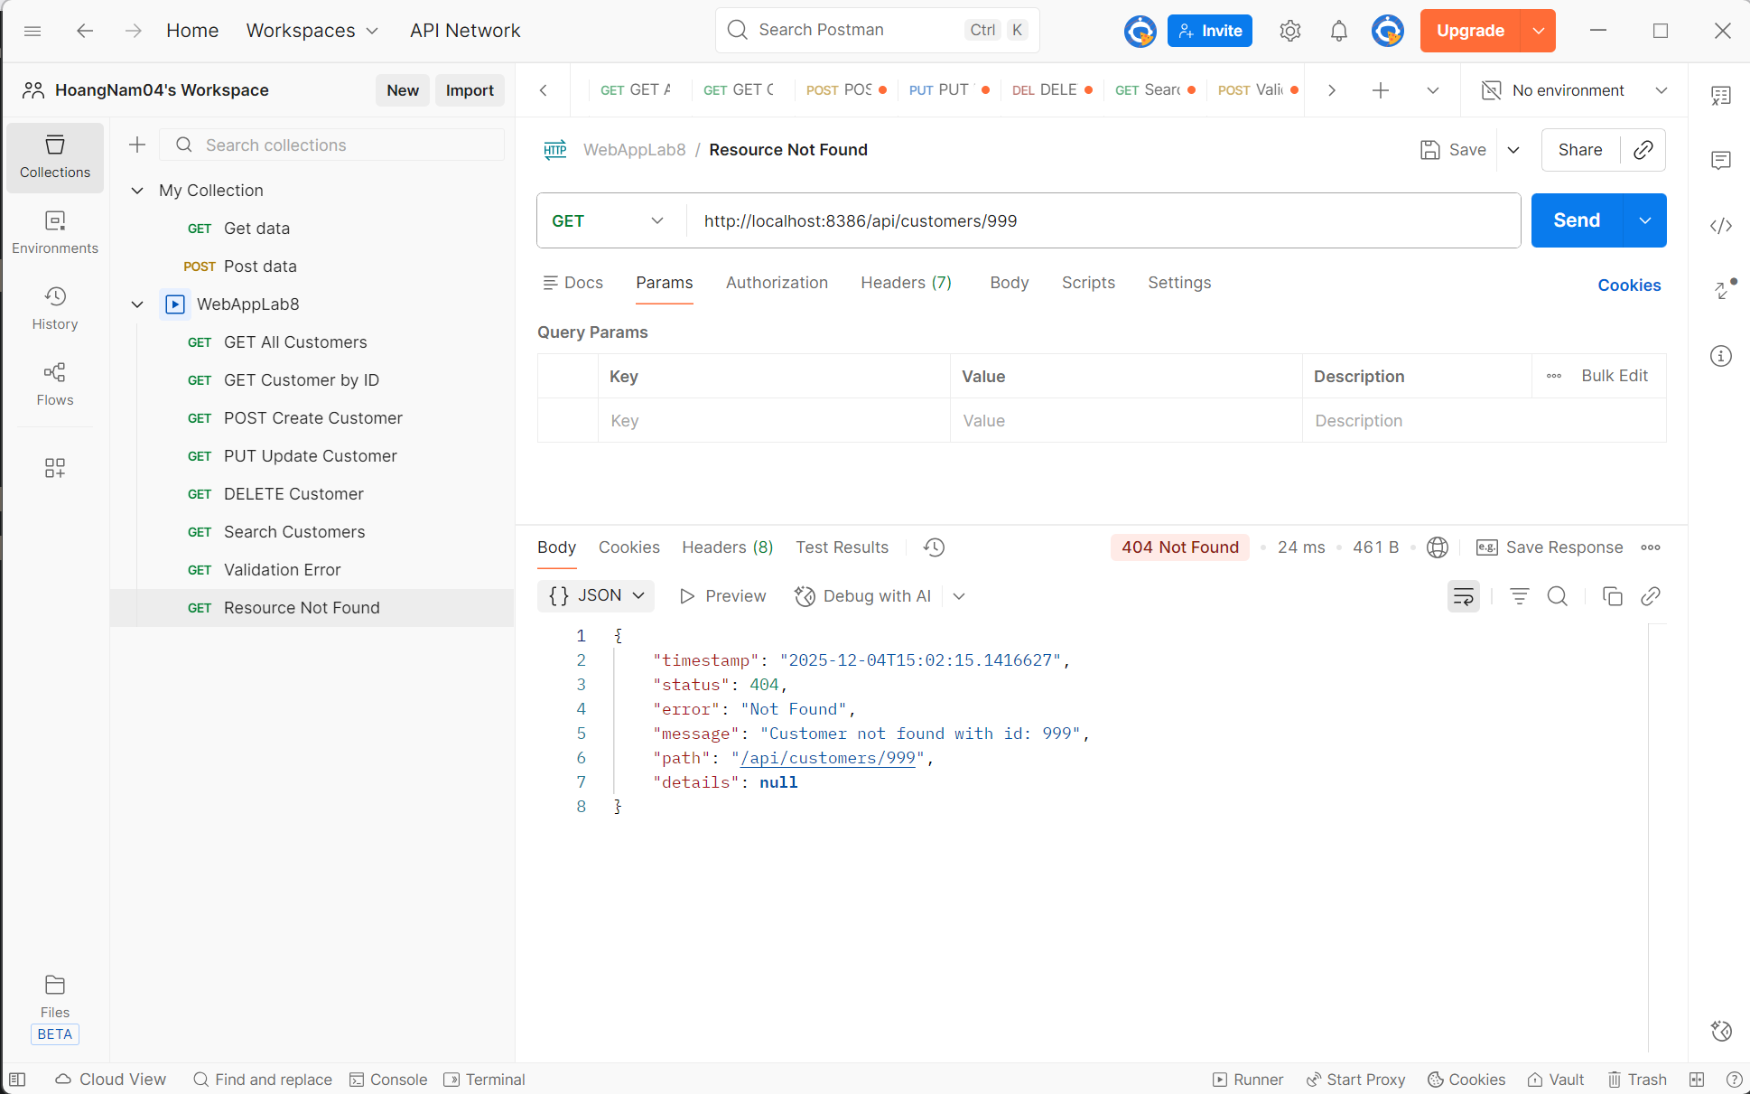
- Objective: To verify how the API handles requests for resources that do not exist in the database.
- Test Execution:
  - Request Method: GET.
  - Request URL: http://localhost:8386/api/customers/999 (ID 999 does not exist).
- Test Result:
  - Status Code: 404 Not Found.
  - Response Time: 24 ms.
- Data Analysis:
  - The server returned a clear error message: "Customer not found with id: 999".
- Conclusion: The API correctly identifies missing resources and returns the standard 404 status code.

Test 9: Duplicate Resource
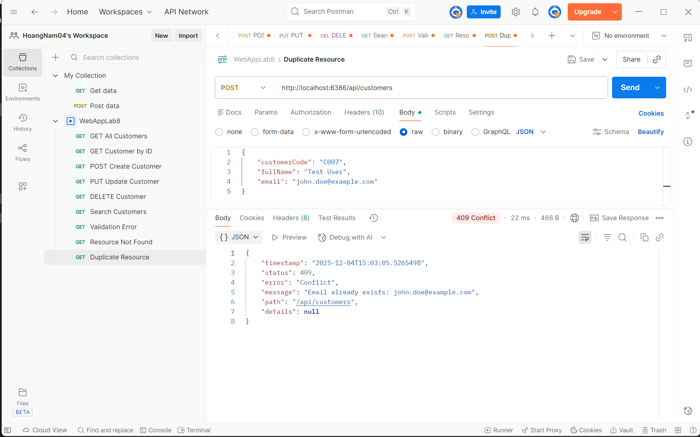

- Objective: To verify that the API prevents the creation of duplicate customer records when a unique constraint (such as an email address) is violated.
- Test Execution:
  - Request Method: POST.
  - Request URL: http://localhost:8386/api/customers.
  - Request Body (JSON): Submitted a new customer payload containing an email address (john.doe@example.com) that already exists in the database.
- Test Result:
  - Status Code: 409 Conflict (Indicates a request conflict with the current state of the target resource).
  - Response Time: 22 ms.
  - Response Format: JSON Error Object.
- Data Analysis: The API correctly identified the conflict and returned a descriptive error message:
  - Message: "Email already exists: john.doe@example.com".
  - Error Type: "Conflict".
- Conclusion: The API correctly enforces unique constraints on critical fields (like email) and returns the appropriate 409 status code to inform the client of the conflict.

